LoRa Proposal

# Problem

I live on the third floor of an apartment building and therefore have no easy way of letting my cat, Arty, out to explore. She loves to walk on the sills if I leave the windows open wide enough and, on one occasion, has fallen out. I'm sure she would love to roam on her own; however, I would like to assure her safety and know if she's nearby so I can let her in or find her if she gets lost.

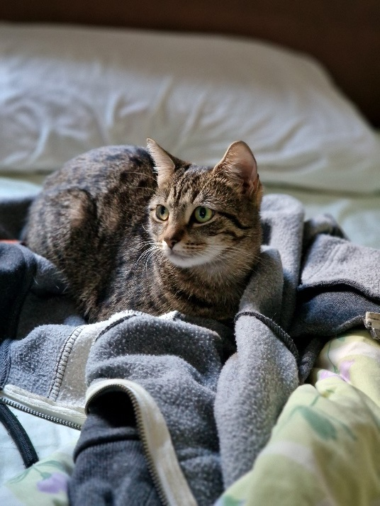

Figure 1: Arty

# Solution

Attach a tracker to Arty so that I can receive remote updates of her location. This will involve a transmitter attached to Arty and a receiver situated at my apartment.

LoRa radio is the ideal technology for this – being long range and low power. Furthermore, this lends itself into custom microcontroller design to achieve the size and power requirements.

# Minimum Requirements

## Transmitter

* Small form factor and low weight – appropriate for a 3kg cat
* Battery powered with suitable lifespan to last at least 5+ hours
* Receive GPS location
* Able to transmit over 1km in an urban environment at regular intervals
* Fire and hazard safe
* Attachable to a vest or collar

## Receiver

* Able to receive signals from the transmitter over a range of distances (5m to 1km+).
* Externally mountable out a window and weatherproof.
* Stable uptime during use.

# Technological Details

I expect to fabricate the transmitter from scratch. Hardware I expect to use:

* Microcontroller like a Cortex-M0 (since I'm familiar with ARM assembly)
* GPS module (small form factors built for quadcopters are common)
* LoRa modulation chip. Something like a SAM R34 has this bundled with an M0 already
* Rechargeable battery (probably Li-ion or LiPo)
* A high gain antenna for the receiver (tuned around 868 Mhz)
* A small antenna for the transmitter – maybe something like a ceramic SMD

# Issues

My primary concerns come down to two things:

* The transmitter failing and therefore location updates stop
* The transmitter is a hazard

Both issues can be explored and appropriately solved with thorough testing. It will be important to ensure the transmitter is suitable for a range of environments, including getting caught in the rain. Provided that the manufacturing is completed to a high-quality standard, the only likely hazard will be the Li-ion battery (if used), which can be quite easily protected with suitable casing.

Further hazards will be explored during development.

An additional concern is that the range will not be suitable, either due to roaming being larger than 1km (unlikely) or the signal failing to pick up through dense urban foliage. Design considerations will need to be made to maximise transmission quality and receiver tuning to pick up weak signals.

# Extensions

If the rest of the project goes well, there are a few extensions I would like to consider:

* Rendering location on a map
* Storing location history to see patterns
* Communicating with the transmitter to make it do something (buzz/flash if it's lost)
* Send me a notification if Arty is nearby (wants to be let in)